2200031128 CH BHAVANA
WEEK 7 TASK 1
Create a React Application named “cricketapp” with the following components:
- ListofPlayers
- Declare an array with 11 players and store details of their names and scores using the map feature of ES6
- Filter the players with scores below 70 using arrow functions of ES6.
- IndianPlayers

  - Display the Odd Team Player and Even Team players using the Destructuring features of ES6
  - Declare two arrays T20players and RanjiTrophy players and merge the two arrays and display them using the Merge feature of ES6

- Creating a web app
- The codes of app.js ,list of player js, Indian player js
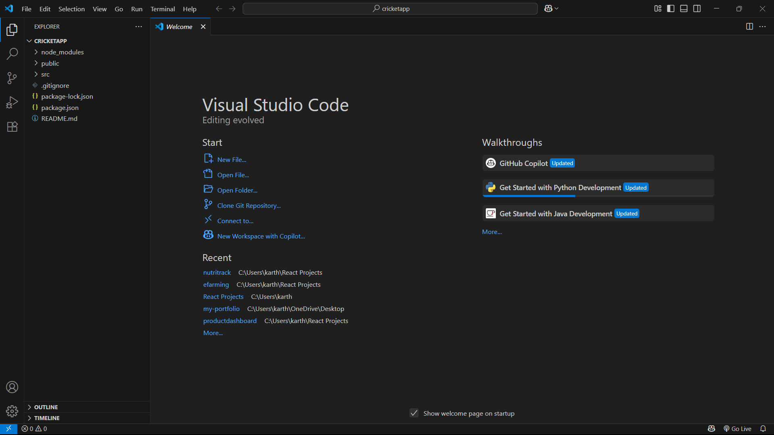
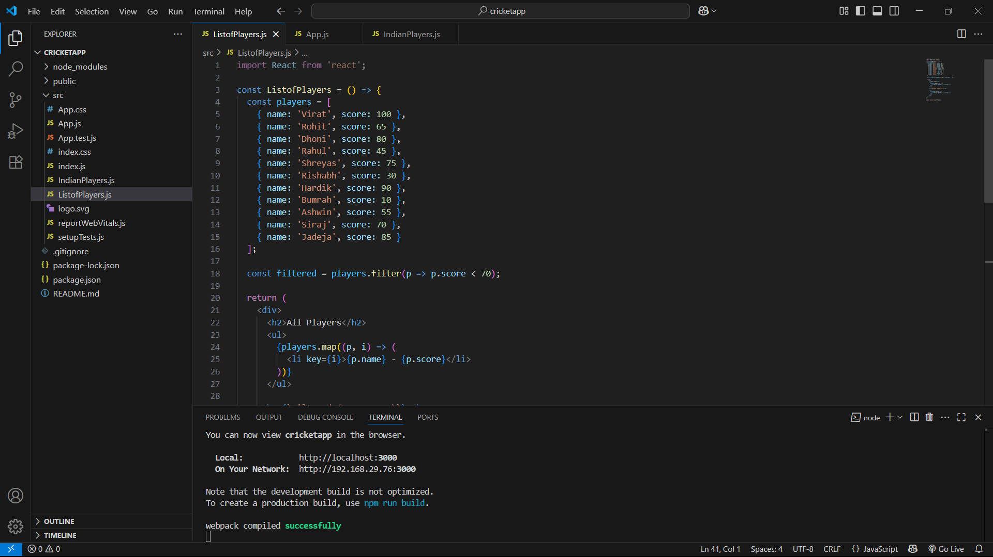
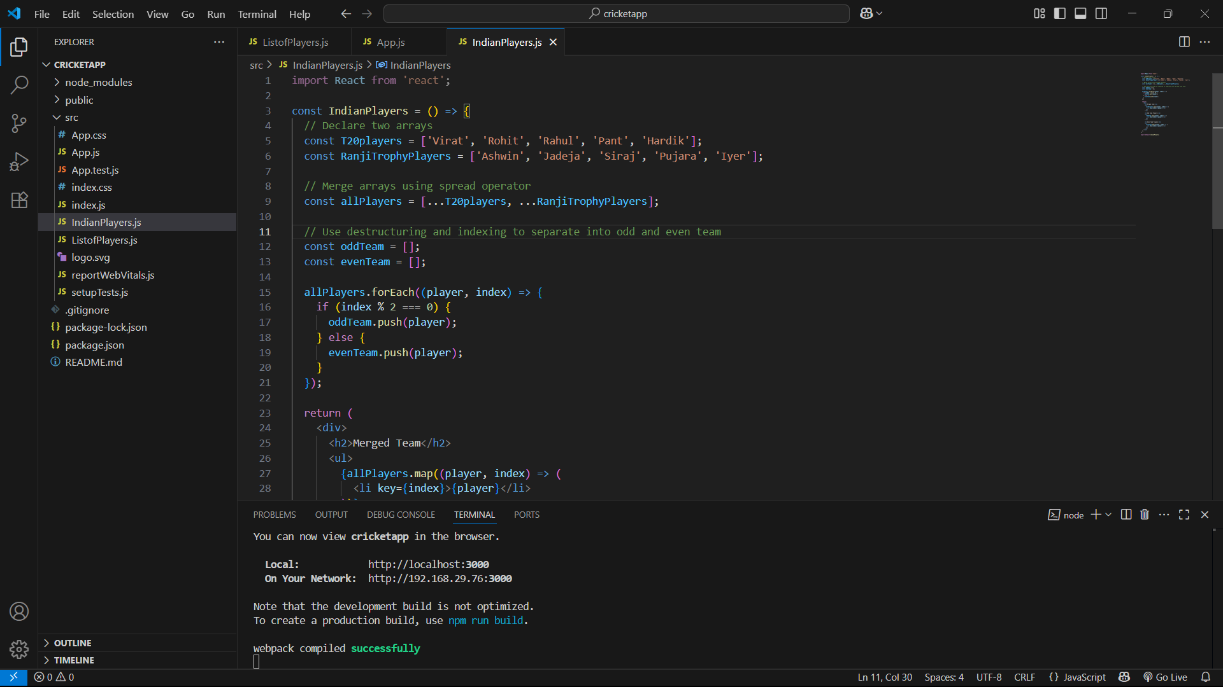

APP.js WHEN FALSE
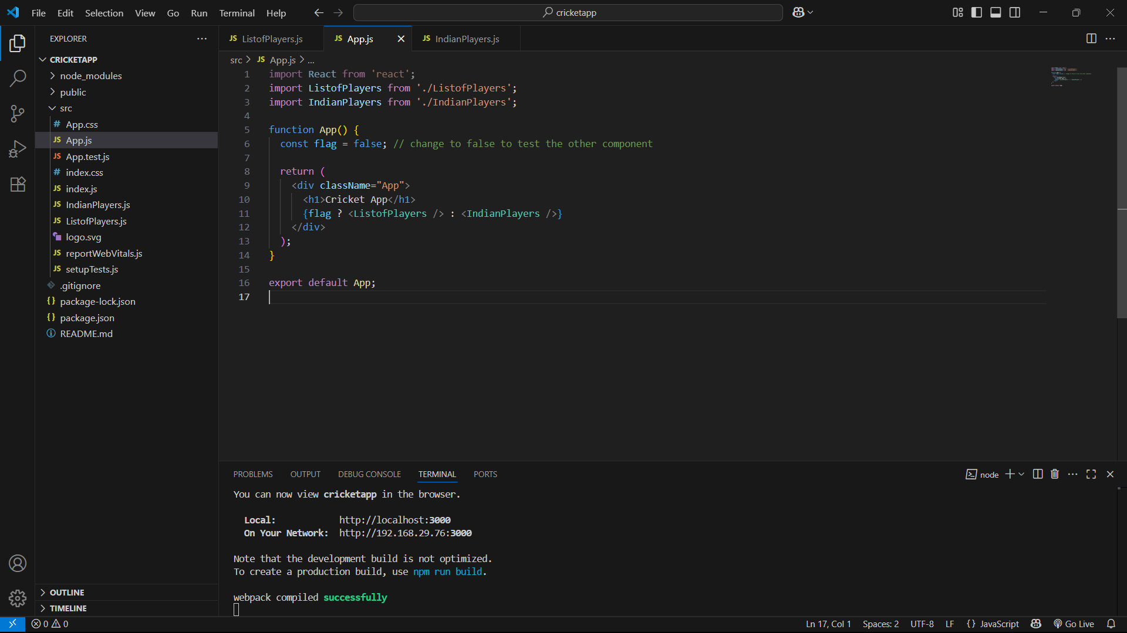
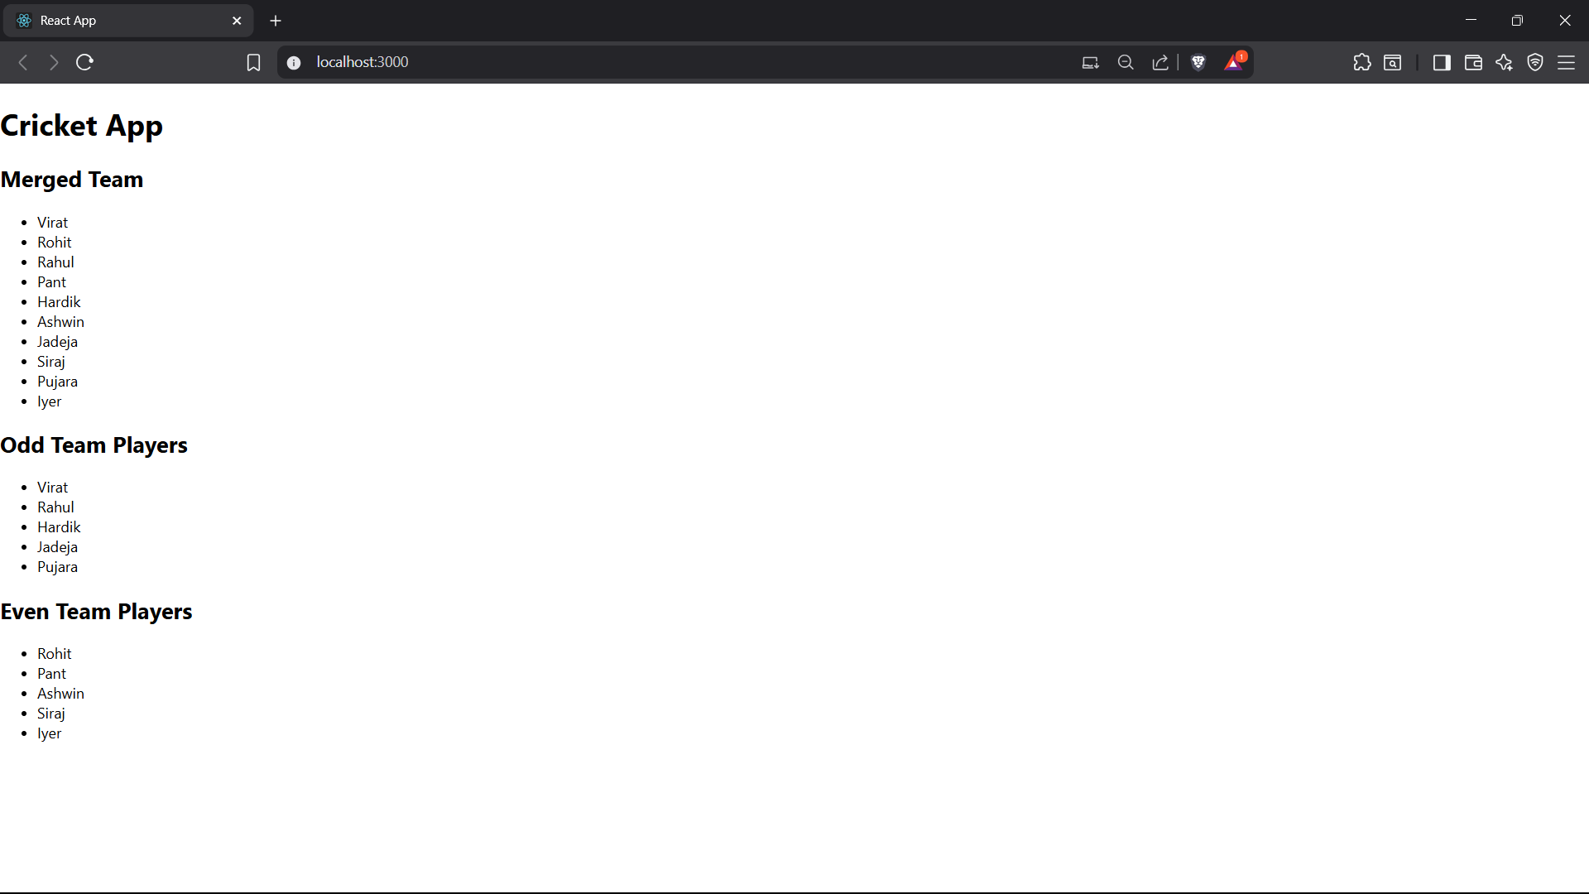

APP.js WHEN TRUE
